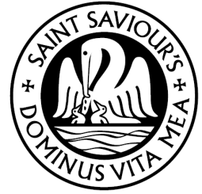
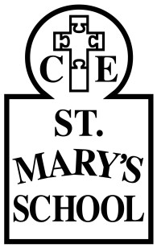
The Federated Schools of St Mary’s and St Saviour’s Ratified: Summer 2016: Review: Annually
Next Review: Summer 2017
RE Policy

School Ethos
• Everyone who comes to work with us is most welcome, but we do understand that not everyone will share all our beliefs. In fact, there are many beliefs within our existing school community.
• We ask that everyone who participates
in our school understands our values and endeavours to join us in living them out, whatever their particular role with us.
• Our shared ethos is shown by a set of values we hold in common. Our whole school community has spent time identifying and exploring them.
• Each school has individual values.

Aims
• We enable children to develop knowledge of the Christian faith and other world religions. We help the children to learn from religion as well as about religion and to reflect on fundamental questions of life.
• The aims of religious education are to help children:
o develop an awareness of spiritual and moral issues
o develop knowledge and understanding of Christianity and other World religions
o develop an understanding of what
it means to be committed to a faith;
o be able to reflect on their own experiences and to develop a personal response to fundamental questions of life;
o develop an understanding and respect for religions and cultural differences in Britain today;
o develop investigative and research skills and to enable them to make reasoned judgements about religious issues;
o have respect for the views of others and to celebrate the diversity in society.
Teaching and Learning
• Religious Education follows the
Teaching and Learning Policy.
• Lessons include Godly Play in which pupils ask, consider and respond to questions that develop their spiritual awareness and personal values.
• Pupils’ learning in school is complemented by visits to local places of worship.
• Teaching and Learning is also supported through visitors from faith communities, especially staff from our partner churches
• RE is taught to all children whatever their ability, and consideration is given
to children with learning difficulties.

In the Curriculum
• We follow the Chelmsford Diocese RE syllabus with the addition of units on other faiths from the Waltham Forest RE (SACRE)
syllabus.
• There are three phases of curriculum
planning (long-term, medium-term and short- term).

Legal Position of RE
• Our school curriculum for religious education meets the requirements of the 1988
Education Reform Act (ERA).
• The ERA stipulates that religious education is compulsory for all children, including those in the reception class who are less than five years old.
• The ERA allows a parent/carer to withdraw their
child from religious education classes if they so wish, although this should only be done once the parent/carer has given written notice to the school governors.
• The ERA states that the RE syllabus should reflect the fact that the religious traditions in Great Britain are in the main Christian, and that it should, at the same time, take account of the teachings and practices of other major religions.

Assessment
• Teachers make informal observations during lessons. Written work is marked and developmental comments given for response. Formal assessment is made at the end of each unit.

